TAA IEP

DocuSign Guide

- Click link DocuSign IEP

- Please fill in Your Name and work email in the Staff section, then the Customer’s (Participant’s) name and email.
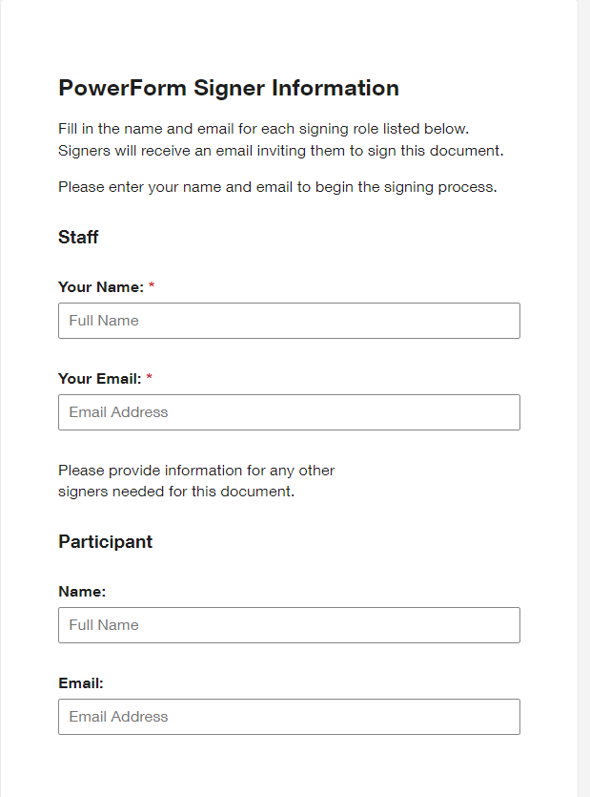

- Once completed, click the button at the bottom of the screen.

- Check the Electronic Disclosure box and click ‘Continue’.

- Complete the IEP form with the customer, filling in all required fields.
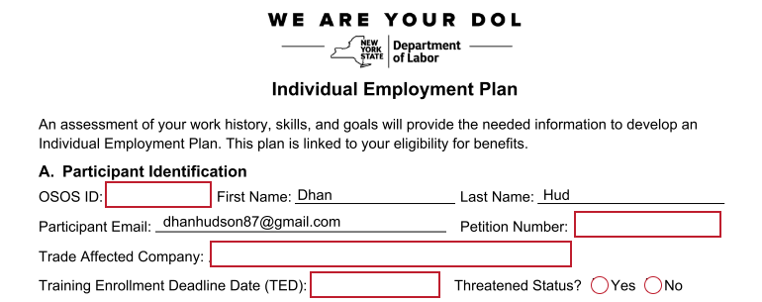

- You must review each item listed on the last page with the customer. This is a list of their responsibilities while in a TAA-approved training program. They will not be able to check these boxes, therefore they must confirm that they agree and understand while reviewing with you.

- Sign the IEP form electronically (click on the ‘Sign’ arrow, then click ‘Adopt and Sign’), and click Finish to continue. Please note, all required fields must be completed in order to proceed.

- The Customer/Participant will receive an email from DocuSign, allowing them to electronically sign the completed IEP form.

- Here is a copy of the email the Customer/Participant will receive:

The New York State Department of Labor is sending you this Individual Employment Plan (IEP) as part of your assessment by the Trade Adjustment Assistance (TAA) program. Please review this form to be sure the information is correct. Once completed, please provide your e-signature at the bottom, then follow the steps below. If you have any questions or experience difficulties signing this form, please contact your TAA Case Manager.
Steps to complete the form:
1. Please click on the “Review Document” button below
2. Check the box under the Electronic Record and Signature Disclosure statement, then click Continue
3. Review the document for accuracy
4. Sign the secure form
5. Click on “Adopt and Sign” to add your e-signature
6. Click the “Finish” button to submit

Thank you

- The Customer/Participant should click ‘Review Document’ in the email they receive to access the IEP form.
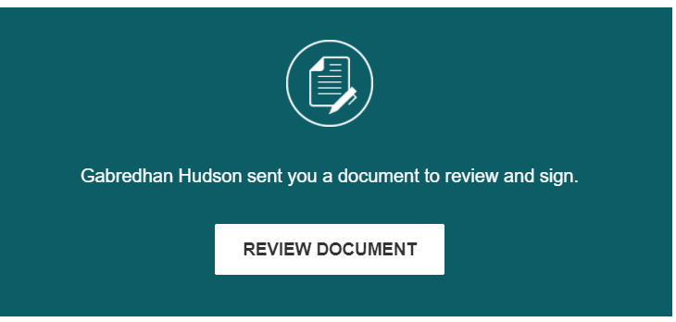

- The Customer/Participant should check the Electronic Disclosure button and click ‘Continue’.
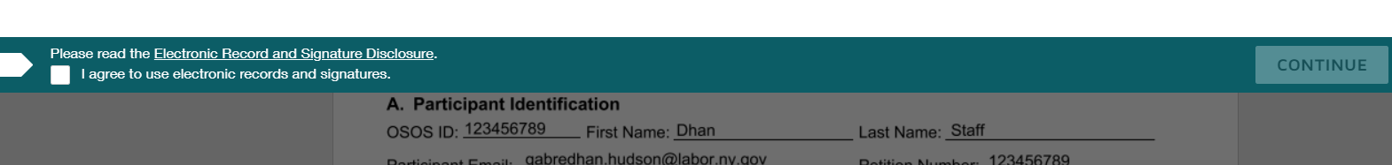

- After the Customer/Participant reviews the form, they electronically sign (click on the ‘Sign’ arrow, then click ‘Adopt and Sign’), and click the Finish button.
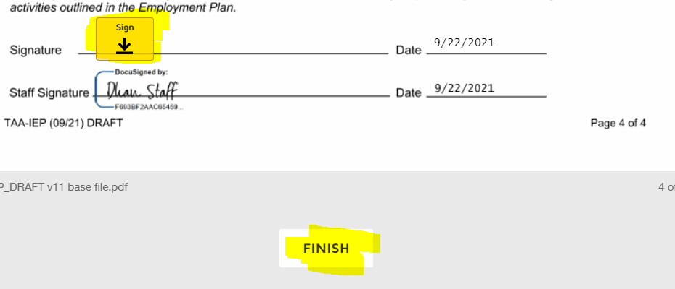

- **If the customer disagrees with the information entered on the IEP, or an error is found, their only option is to go to the ‘Other Actions’ drop-down menu on the right side of the screen and click ‘Decline to Sign’ and then ‘Continue’. They must also enter a reason why they are declining to sign. This is the only way corrections can be made.
PLEASE NOTE: If the customer chooses this option, a new IEP must be completed.

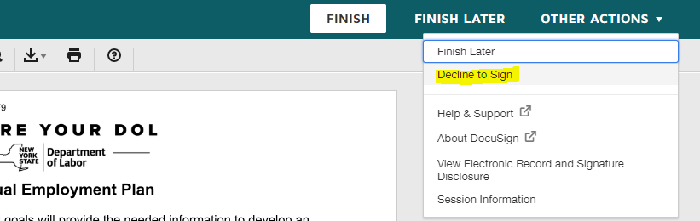

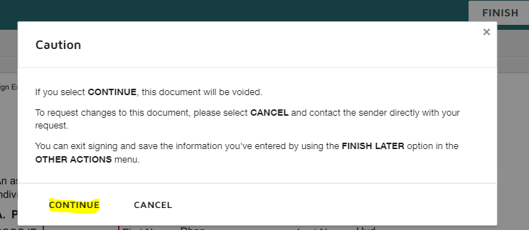

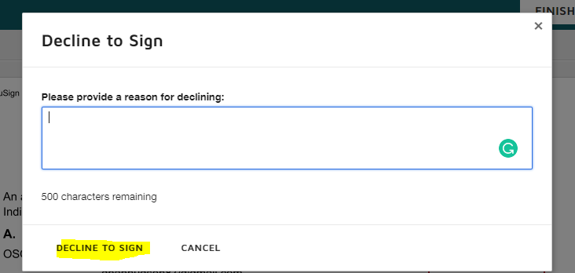

- Once the customer signs the IEP, a completion email is sent to Staff’s work email. For your reference, the customer’s name will appear in the subject line.
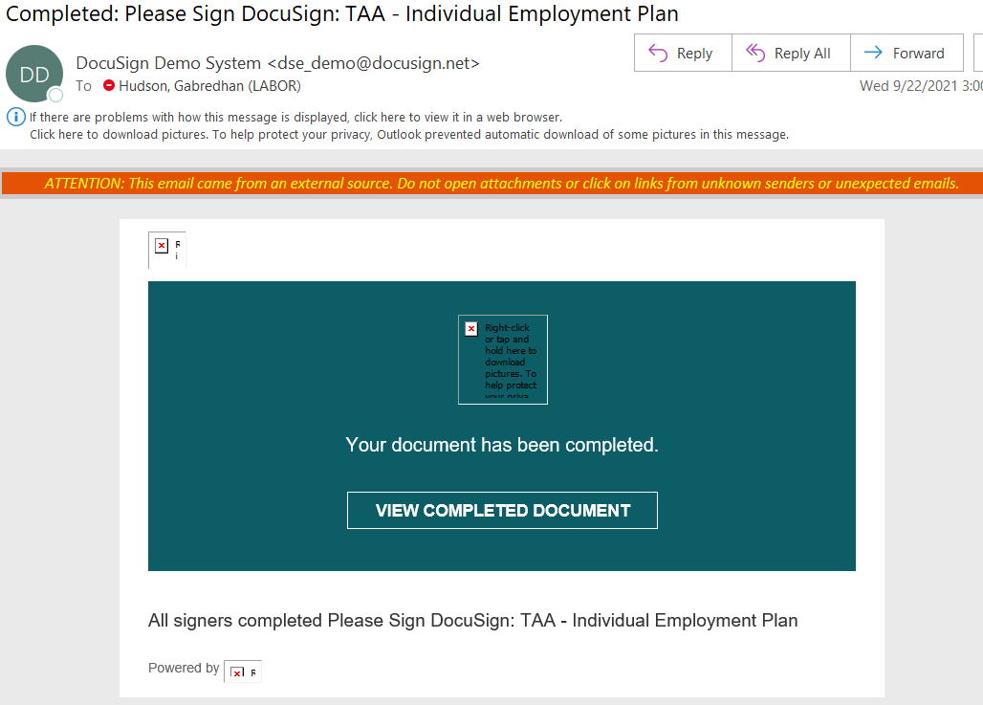

- Click on ‘View Completed Document’.

- Click on the down arrow button at the top of the screen, then click ‘Combined PDF’ to download the IEP form as a pdf.
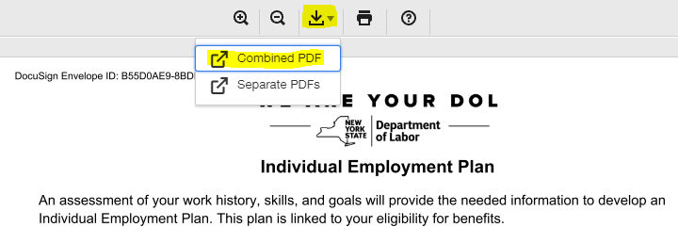

- A dialogue box will be displayed. Select the ‘Save File’ radio button, then click ‘Ok’.
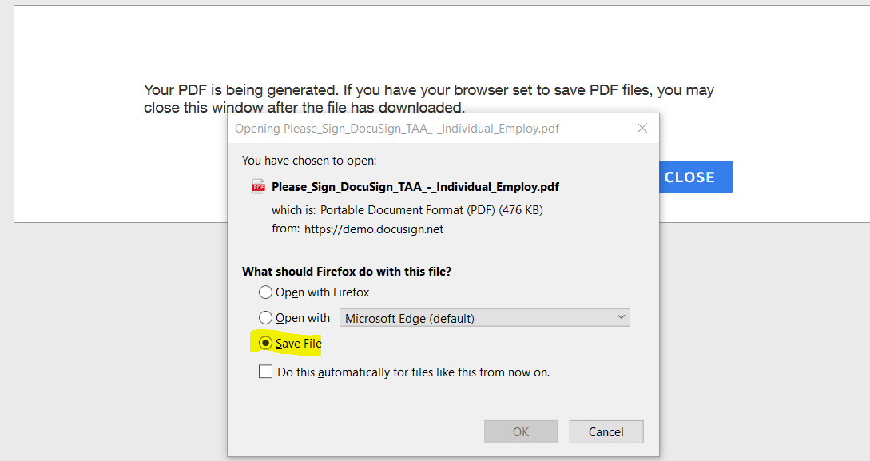

- By default, the file will save to your Downloads folder, unless you manually choose a different location.

- In OSOS, navigate to the Customer module, Customer Detail window, then the Attachments tab (2 tabs past the Comments tab).

- Click on the ‘Add Attachment’ button, then go to the ‘Attachment Type’ drop down at the top of the page. Select ‘Individual Employment Plan (IEP)’.

- Add a comment in the ‘Notes’ box, then click ‘Upload Attachment’.

- If you are unable to upload the Completed IEP Document in OSOS, please follow the steps in the Attachment Guide below. (If the Attachment Tab in OSOS is greyed out, you may not have access to it.) If you have not uploaded a document to OSOS before, the guide will help you set up your system. If you are still unsuccessful, please include the completed IEP with the initial funding request for your customer and TAA Central Office will upload the document for you.
Attachment Tab OSOS Guide

- If you have questions regarding DocuSign itself, please use the following knowledge-based link. This link will search across DocuSign support articles, community conversations, knowledge market and DocuSign University: https://support.docusign.com/en/. Please use the search bar at the top of the screen.

