Career Unit Plan – Introduction to Careers in the US Healthcare System

Teacher Name: Christine Bosco
Grade Level(s): 11-12 | Subject/Course: CTE/Physical Therapy and Rehabilitative Profession |  | Unit Plan: Career Exploration/ Career day Project
Resources needed:  On-site people, facilities, tools, technology, materials, community connections | Chromebooks  Internet  Software: Google slides or PowerPoint  O*Net  Career One Stop  Index cards  Complete pathways graphic  Classes requirement chart
Learning Standards: | NYS CDOS Standard 1: Career Development Students will be knowledgeable about the world of work, explore career options, and relate personal skills, aptitudes, and abilities to future career decisions.  Career and Community Connections  2a) Identify and use career resources to obtain information about careers and employment trends  Employability skills 3a) Identify personal characteristics such as abilities, interests, and values and examine how they might impact career choices  NYS Literacy Standard 7  Integrate and evaluate content presented in diverse media and formats, including across multiple texts
Big Idea & Authentic Purpose:  Why does this matter to your students?  How will this be helpful to your students? | Students will start thinking and exploring what they want to do for a job or career.  Students will learn about multiple jobs in the healthcare industry and compare and contrasts the pros and cons of the careers, applying this to their inventory findings.
Type of Career Content  - Career specific | Experts:  Students will work individually (in groups of 2), interviewing (6 if group of 2) people in the hospital in various career titles. They will create 10 questions to ask each person. This can be done in person, zoom, or through email.
Relevancy:  How does it connect to students' lives? | The lesson provides students with resources to gain knowledge and skills about possible career paths based upon their interests or strengths. They will be able to access these resources throughout their life and career journey. They will also be exploring similar career to differentiate where they feel fits them best.
Objectives:  Objectives Day 1: Students will identify personal skills, strengths, and abilities, and relate those to career exploration and post-secondary education choices  Use O*Net interest inventory and mynextmove.org  Objective Day 2: Students will identify personal skills, strengths, and abilities, and relate those to career exploration and post-secondary education choices  Objective Day 3 and 4: Students will apply what they have learned about their personal skills, strengths, and abilities to career exploration activities and post-secondary education choices |  | Assessment:  Day 1 –  Submit a screenshot of their O*Net interest inventory.  Exit ticket- Submit 3 careers that you are interested in that align with your interest inventory. State if you feel it matches up with your personality trait and explain  Day 2- Draft 10 questions to ask at your healthcare interviews, and the three careers you are interviewing and turn in via Google Classroom. They will create pros and cons charts about the careers.  Day 3- Create One Page Jamboard or Google slide about what you learned about the industry from the expert. These will be posted around the room in gallery walk format. Students will walk around and find 5 things they learned from these.  Day 4- Presentation on the career- Option for PowerPoint, poster, or video  During presentation, students will complete I like, I wonder, I learned protocol for each presentation.  Later date- 8th grade career and 10th grade presentation- each students will present in a career fair format, along with combining a hands on activity
Knowledge Construction: How are students going to construct content knowledge and practice it

Day 1: Students shown VIA below. They pick our their top 6 traits, and have someone that knows them- friend, classmate, family pick out top 6 traits.
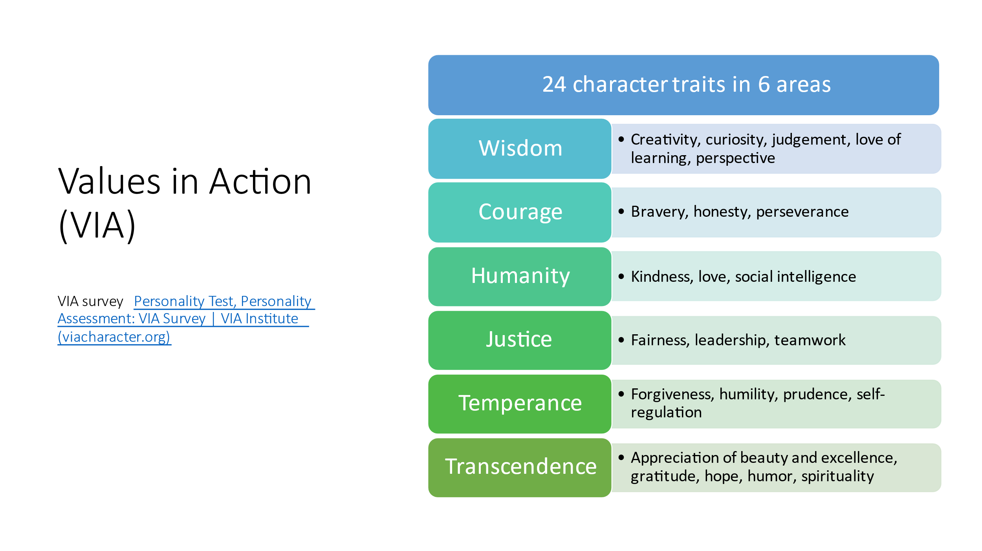

Complete O*Net inventory- find and identify top 3 occupational interests- take a screenshot and submit to your instructor

Identify 30 careers within healthcare- the hospital and other settings.

Science Careers (sciencebuddies.org)
Home - New York Health Careers (healthcareersinfo.net)

Day 2

Prepare for interview- Pick 3 (Individual) or 6 (group of 2) professionals and prepare 10 questions for them to answer. Complete a pros and cons chart for each career. Create a one page Jamboard for each career about what you learned. These will be posted in gallery walk format. Students write on an index card 5 things they learned about various occupations while participating in the gallery walk.

Day 3
Pick one career that aligns with your findings based upon the inventories you have completed. Research the career. Compare a presentation about your chosen career- can use powerpoint, poster or video. Requirements for your presentation:

- Career outlook
- Wages/money
- Job duties
- Education/training
- Soft skills required
- Location/where?/regions
Resources given:
Career Zone
O*Net
NYS Department of Labor Website
Career One Stop

Also about your career, complete a pathways chart of how a person can get to their career from your viewpoint sitting here in high school. Include multiple options if applicable. Also complete the classes required chart for yourself using the research you found in the pathways (i.e how many years of math does it take to get into a training program for this career).

Day 4- Presentation Day
Each student gives their presentation
Complete I like, I wonder, I learned protocol

Revise and reflect

Present on 8th - 10th grade career days in career fair form. Each student will also come up with a hands-on activity to do with students during the presentations.

Requirements | Years Required | 7th | 8th | 9th | 10th | 11th | 12th
History/Social Science | 2 Years
English | 4 Years
Mathematics | 3 Years
Lab Science | 2 Years
Language | 2 years
Visual or performing arts | 1 Year
College Prep Electives | 1 Year

Example of pathways – find local opportunities for the pathways

