Career Unit Plan – “Never Work a Day in Your Life”

Teacher Name: Mary Jo Nicholson, Megan Osetek, Philip Kinane, and Christine Bosco
Grade Level(s): 7-9 | Subject/Course: CTE/all |  | Unit Plan: Career Exploration
Resources needed:  On-site people, facilities, tools, technology, materials, community connections | Chromebooks  Internet  Software: Google slides or PowerPoint  O*Net  Career One Stop
Learning Standards: | NYS CDOS Standard 1: Career Development  Students will be knowledgeable about the world of work, explore career options, and relate personal skills, aptitudes, and abilities to future career decisions.  Career and Community Connections  2a) Identify and use career resources to obtain information about careers and employment trends  Employability skills  3a) Identify personal characteristics such as abilities, interests, and values and examine how they might impact career choices  Career Technical Core (CCTC) Standards: Career Ready Practices  2). Apply appropriate academic and technical skills.  NYS Literacy Standard 7  Integrate and evaluate content presented in diverse media and formats, including across multiple texts
Big Idea & Authentic Purpose:  Why does this matter to your students?  How will this be helpful to your students? | Students will start thinking and exploring what they want to do for a job or career.  ‘Have you ever heard the saying- If you like what you’re doing, you’ll never work a day in your life’
Type of Career Content  - Career specific  - Career psychology  - Career skills | Experts:  Who can you connect with in order to bring in an outside voice?  Zoom with former students and/or professionals  Guest speakers from local industries
Relevancy:  How does it connect to students' lives? | The lesson provides students with resources to gain knowledge and skills about possible career paths based upon their interests or strengths. They will be able to access these resources throughout their life and career journey.
Objectives:  Objective Day 1: Using any of the options (checklist, VIA.), the student will identify their ‘positive” personality traits and areas of strengths and weaknesses.  Objectives Day 2: Students will identify personal skills, strengths, and abilities, and relate those to career exploration and post-secondary education choices  Use O*Net interest inventory and mynextmove.org  Objective Day 3 and 4: Students will apply what they have learned about their personal skills, strengths, and abilities to career exploration activities and post-secondary education choices |  | Assessment:  Day 1 Google Form- Students go through each category and list their top 6 personality traits. These will be imported into the instructor’s spreadsheet.  Day 2 –  Submit a screenshot of their O*Net interest inventory.  Exit ticket- Submit 3 careers that you are interested in that align with your interest inventory. State if you feel it matches up with your personality trait and explain  Day 3- Draft Presentation on career  The presentation must include required elements listed below  Day 4- Give the presentation  Each audience member needs to ask at least 3 questions throughout the all the presentations and summarize (using complete sentences) the answers discussed about fields or careers.
Knowledge Construction: How are students going to construct content knowledge and practice it

Day 1: Using options (checklist, VIA, Careerzone/O*Net (work interest values), the student will identify their ‘positive” personality traits and areas of strengths and weaknesses.
They can rate themselves based upon the 24 traits in the 6 categories.
www.viacharacter.org
Class discussion: Examples of personality traits and discussion- Discuss careers per each trait
Positive Personality Profile Guide
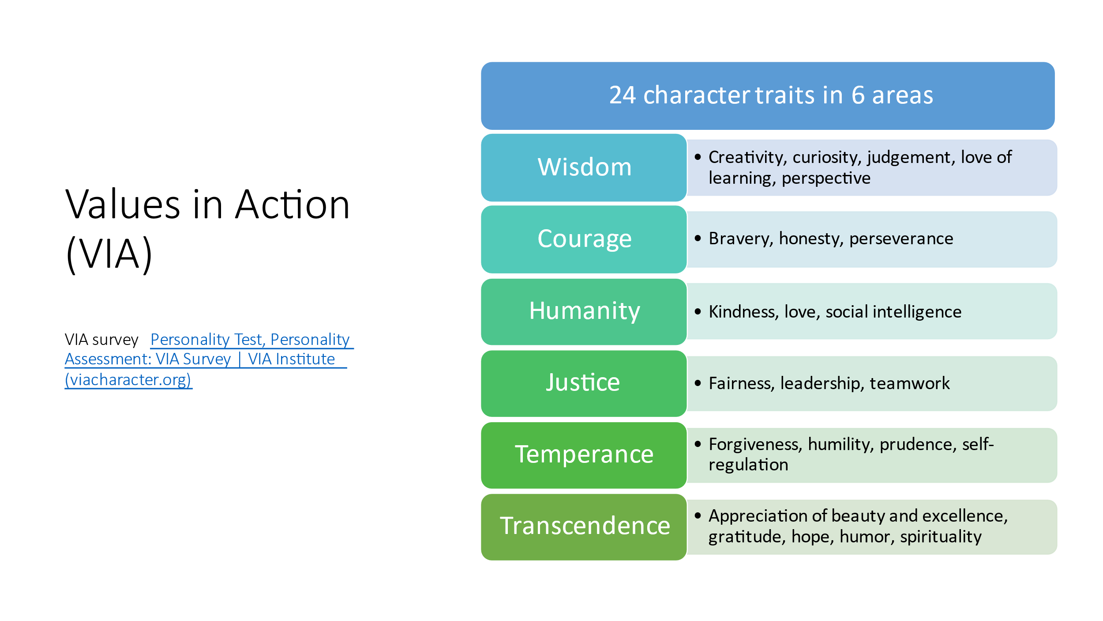

OR make your own presentation on positive personality traits
Students can rate themselves and give one example when they used the strength.

Students will fill out a Google form stating their top 6 personality traits.

Day 2

Complete O*Net inventory- find and identify top 3 occupational interests- take a screenshot and submit to your instructor

Search – Career one stop, O*Net, Careerzone, mynextmove.org

Exit ticket- Submit 3 careers that you are interested in that align with your interest inventory. State if you feel it matches up with your personality traits and explain.

Day 3
Pick one career that aligns with your findings based upon the inventories you have completed. Research the career. Prepare a presentation about your chosen career. Requirements for your presentation:

- Career outlook
- Wages/money
- Job duties
- Education/training
- Soft skills required
- Location/where?/regions

Video/interview former students.

Videos to watch as a group and posted on Google Classroom to view later:
Good Presentation VS Bad Presentation * - YouTube

HOW TO Give a Great Presentation - 7 Presentation Skills and Tips to Leave an Impression - YouTube

Day 4- Presentation Day
Each student gives their presentation and is prepared to answer questions.
At least 3 questions should be asked to each presenter about the presentation.

End of Lesson- KWL Chart on any career presented.

