Name:
“Where can I work after graduation?”
Part I Directions: There are QR codes placed around the classroom that detail different types of job opportunities around our region. At each station there will be a short reading and/or video that details what that business does, what they are looking for in an employee, and more information. Record and answer each question for the companies the boxes below. We will use the information you record to debrief as a class.
Company | What does the company/organization do? | What skills do they want in an employee? | Does this company require a college degree? | What types of salaries does the company offer? | How do you apply? | Interest level
Municipal Employment

Name:
“Where can I work after graduation?”
Part II Directions: Let’s go a step further. Choose four companies that sparked your interest. In this portion, you can investigate more about what working for that employer is like. Head to the company website and record information below.
Company/Organization
What interested you most about this company/organization? Be specific.

Do they have jobs postings page available? What positions are available? Which one(s) interest you? Include some information about the salary, benefits, and other important information below as well.

Will you need any training/degree? If so, where will you obtain the training required?

What skills do you have that will make you a good fit for this company/organization? Try ranking your strengths below as well.

What might your weaknesses be or barriers to working for this company? How can you improve?

Company/Organization
What interested you most about this company/organization? Be specific.

Do they have jobs postings page available? What positions are available? Which one(s) interest you? Include some information about the salary, benefits, and other important information below as well.

Will you need any training/degree? If so, where will you obtain the training required?

What skills do you have that will make you a good fit for this company/organization? Try ranking your strengths below as well.

What might your weaknesses be or barriers to working for this company? How can you improve?

Company/Organization
What interested you most about this company/organization? Be specific.

Do they have jobs postings page available? What positions are available? Which one(s) interest you? Include some information about the salary, benefits, and other important information below as well.

Will you need any training/degree? If so, where will you obtain the training required?

What skills do you have that will make you a good fit for this company/organization? Try ranking your strengths below as well.

What might your weaknesses be or barriers to working for this company? How can you improve?

Company/Organization
What interested you most about this company/organization? Be specific.

Do they have jobs postings page available? What positions are available? Which one(s) interest you? Include some information about the salary, benefits, and other important information below as well.

Will you need any training/degree? If so, where will you obtain the training required?

What skills do you have that will make you a good fit for this company/organization? Try ranking your strengths below as well.

What might your weaknesses be or barriers to working for this company? How can you improve?

Rubric Directions: Below provide evidence for part I of this project. In the boxes reflect and assess your work during the lesson and debrief portion. Provide specific evidence as to why you think you should score in that category.
 | 3 (Exceeds) | 2 (Meets) | 1 (Does Not Meet)
Career Exploration
Did you complete all portions of the assignment? Did you investigate the careers available for the companies you chose?
Self-Reflection
Were you simply copying information, or did you take the time to really think about what type of career you might want with one of the companies?
Engagement
Were you engaged while recording information? Were you an active participant in the debrief portion?

Rubric Directions: Below provide evidence for part II of this project. In the boxes reflect and assess your work during the lesson and debrief portion. Provide specific evidence as to why you think you should score in that category.
 | 3 (Exceeds) | 2 (Meets) | 1 (Does Not Meet)
Career Exploration & Requirements
Did you complete all portions of the assignment? Did you go in depth with the categories and provide the necessary information?
Self-Reflection
Did you take more than a few moments to reflect on what skills would make you a good fit or a barrier to a certain job? This is crucial for interviews.
Career Analysis
Did you analyze what might make you a strong candidate and why you were interested in that career?
Engagement
Were you engaged while recording information? Were you an active participant in the debrief portion?

Rochester Area Businesses for Lesson with links-Canva Sites
Local 86 | https://doltest1.my.canva.site/
NYS Jobs | https://doltest1.my.canva.site/new-york-state
GW Lisk | https://doltest1.my.canva.site/gw-lisk
Takeform | https://doltest1.my.canva.site/takeform
Optimax | https://doltest1.my.canva.site/optimax
Advanced Rubber Products | https://doltest1.my.canva.site/arp-products

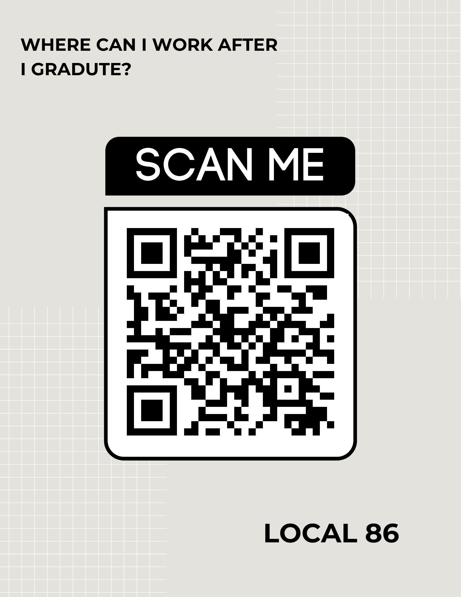
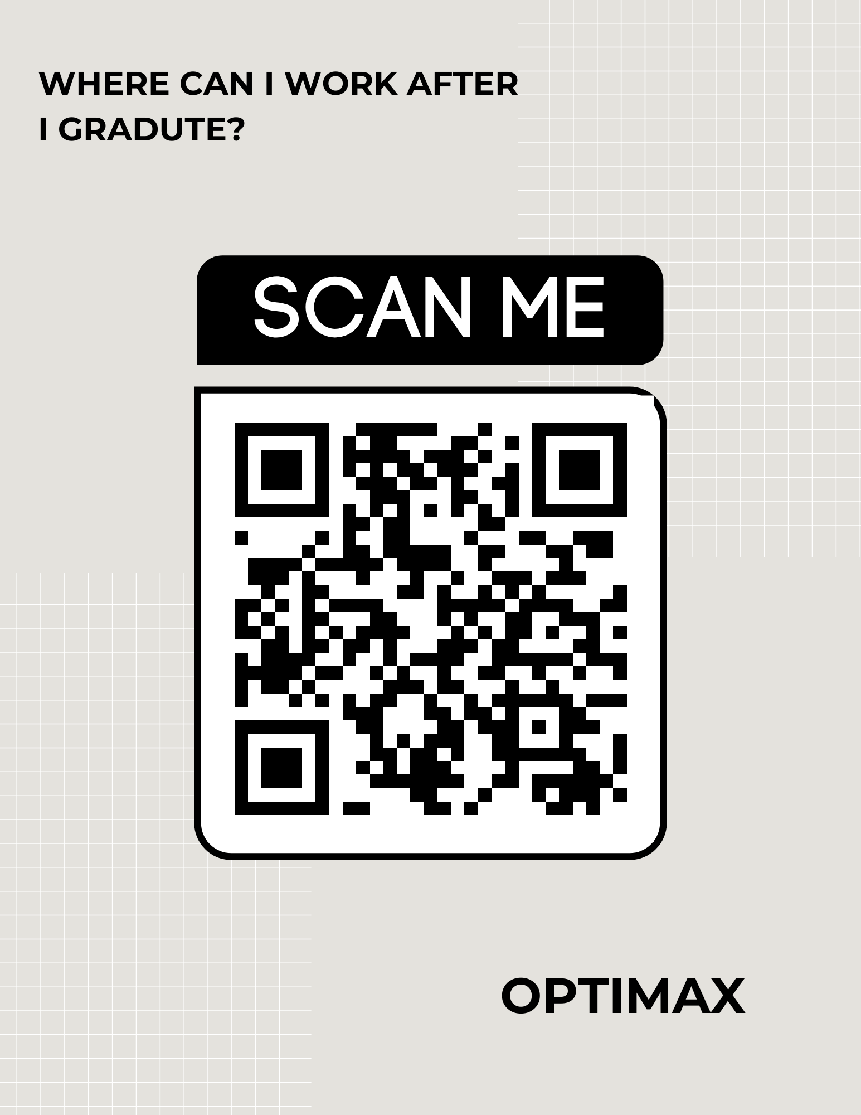
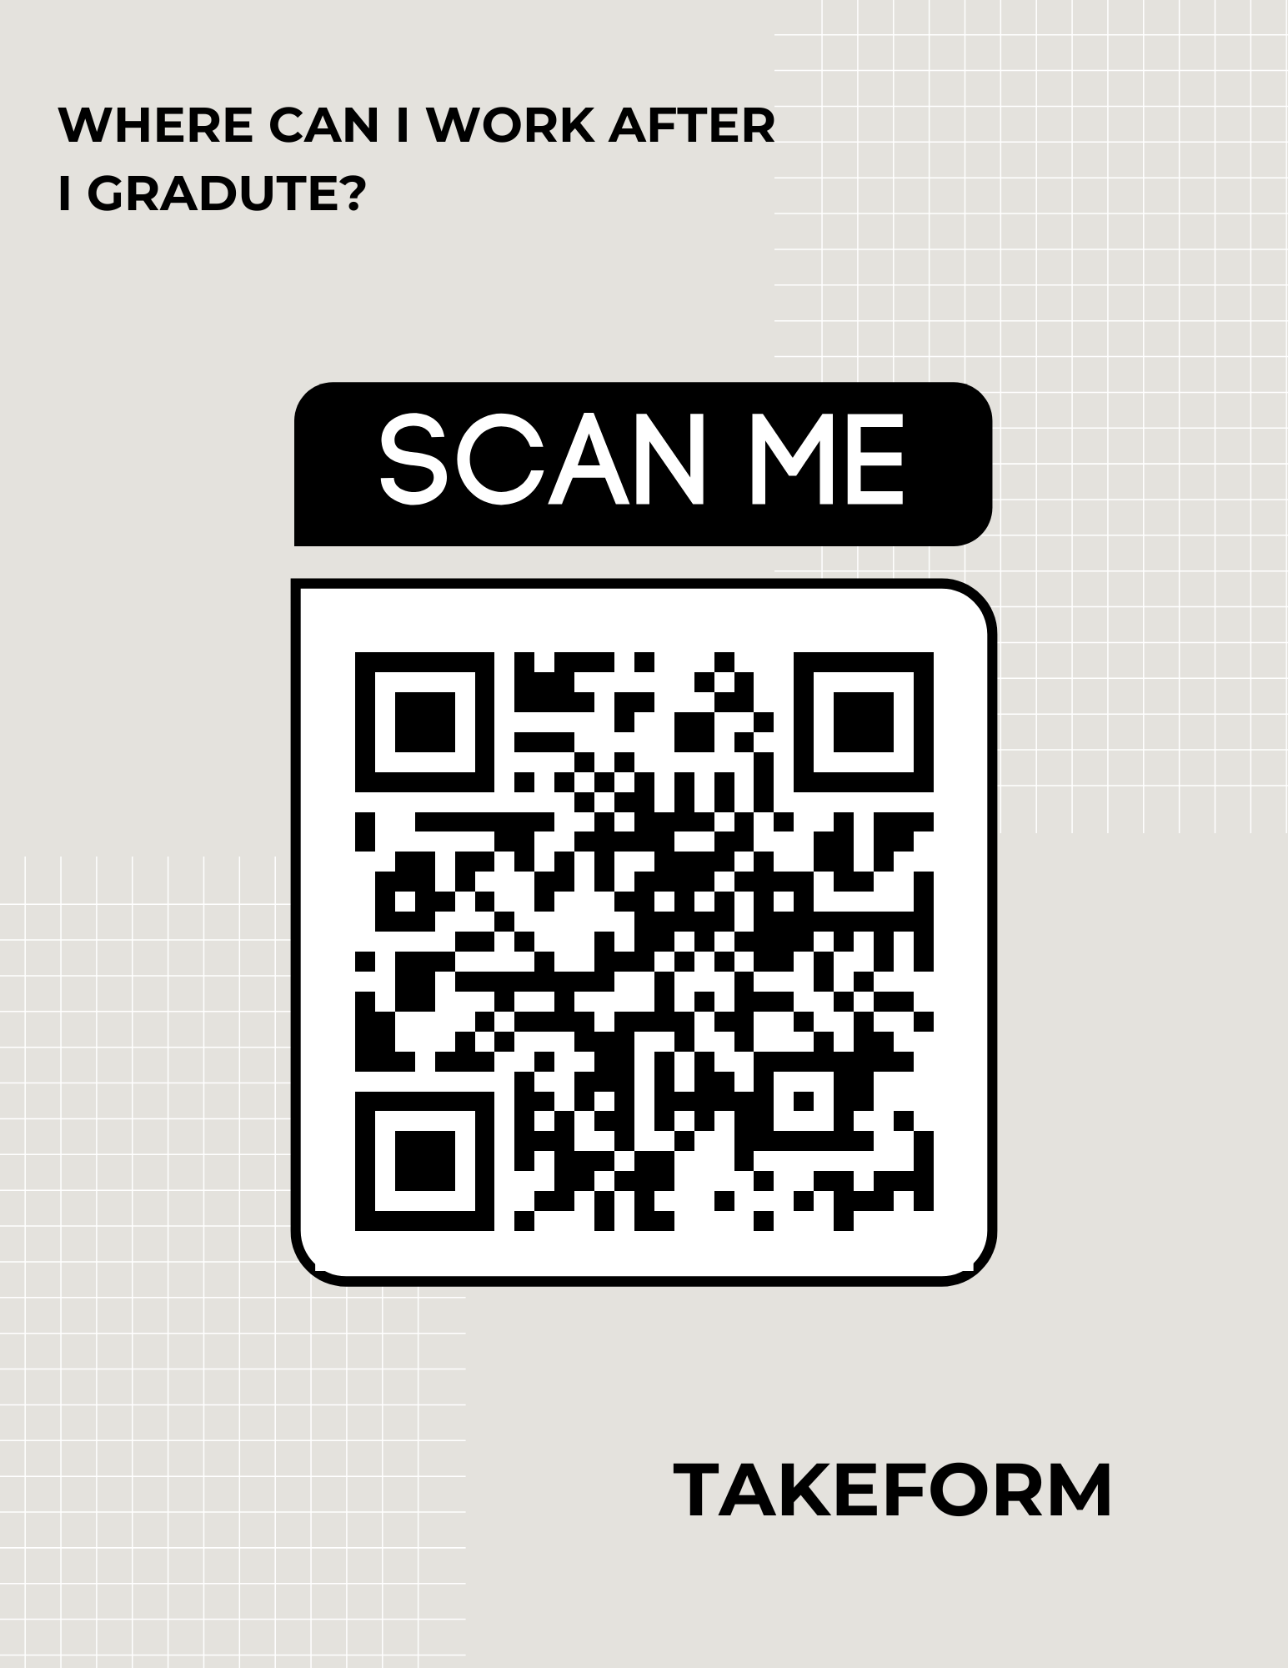
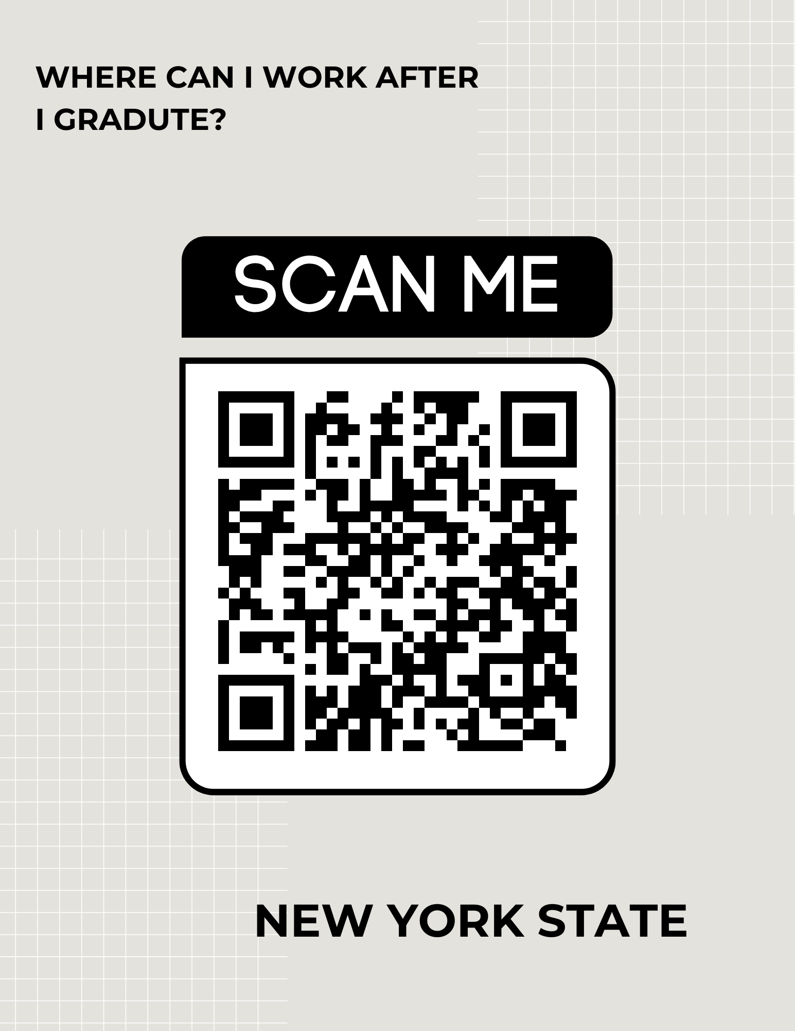
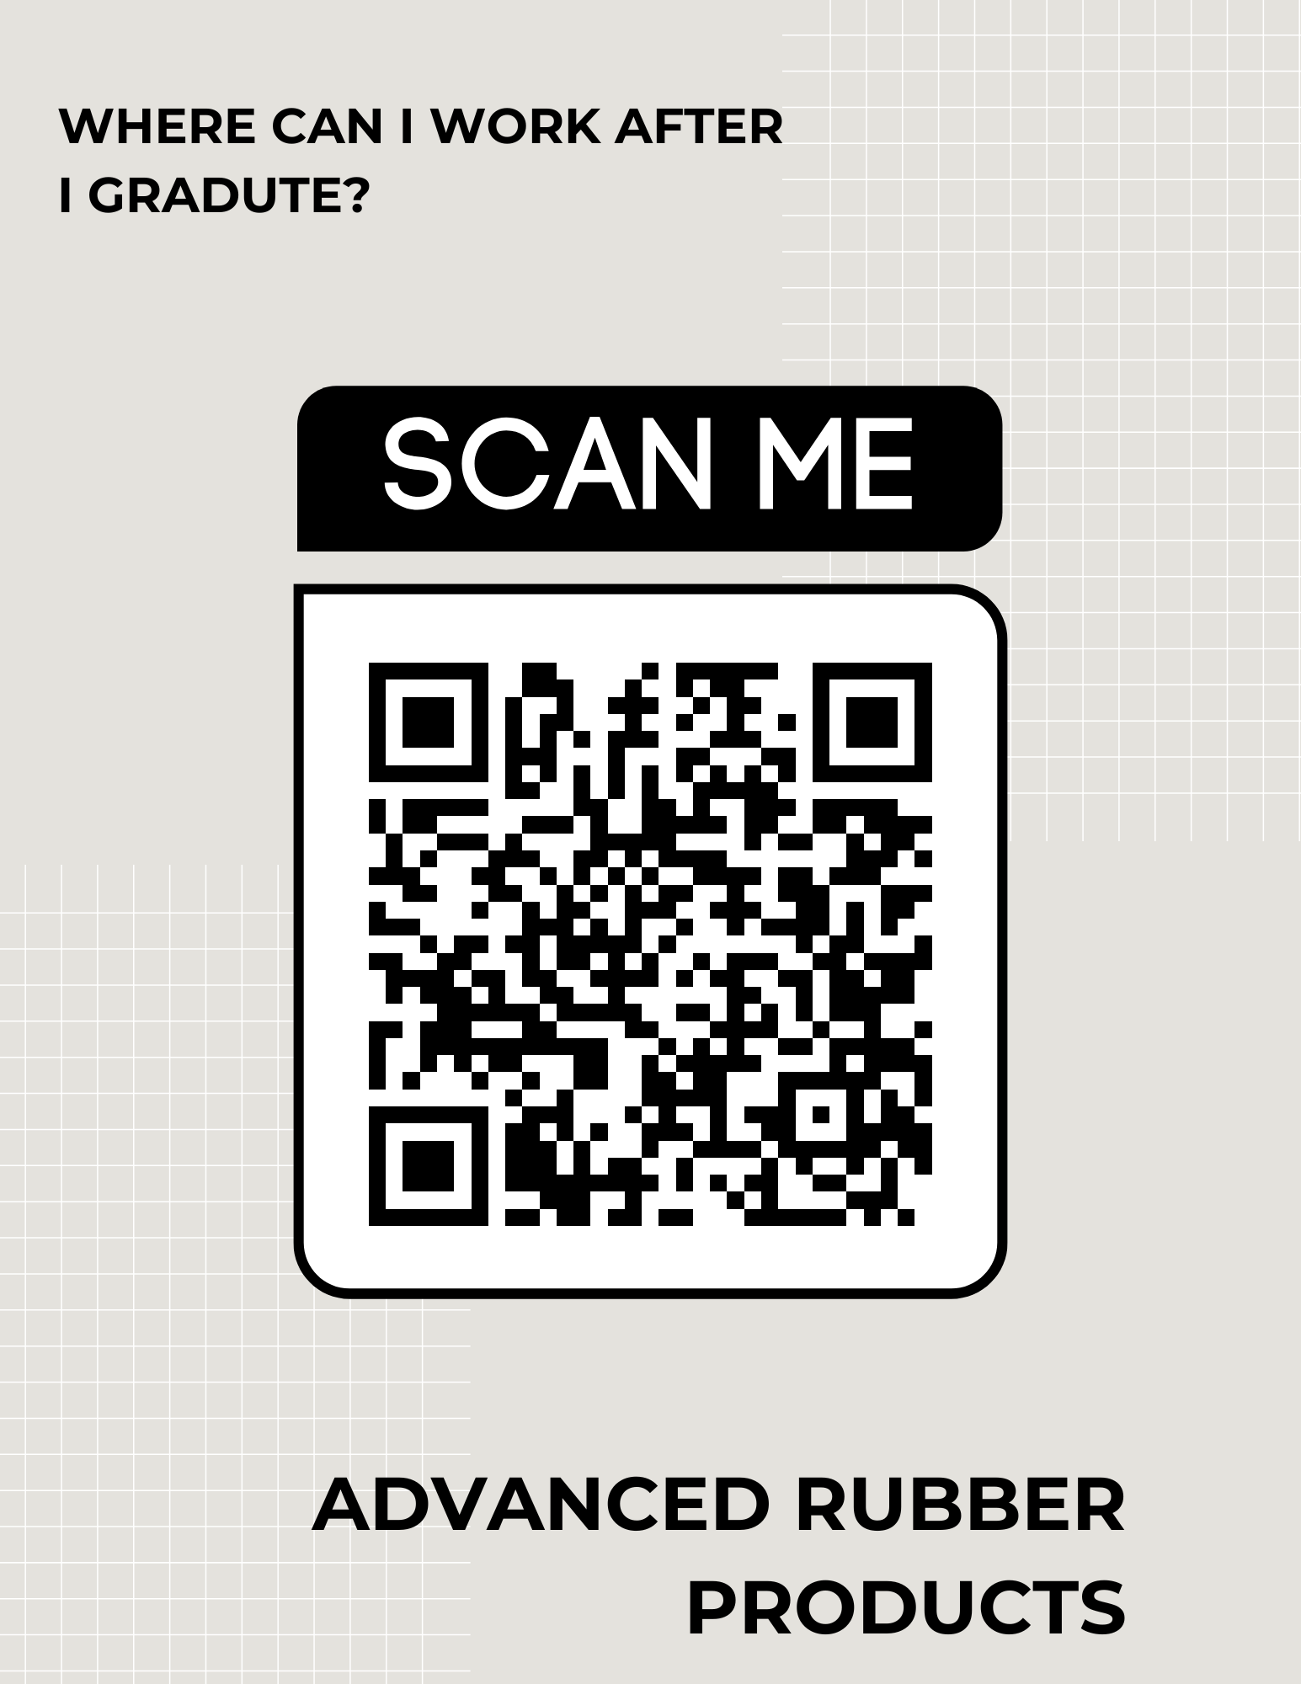
Career Lesson – Where can I work after graduation?

Teacher Name: Nick D’Amuro |  |  | Duration (in minutes):45 minutes-1 hour (day one enrichment portion will take more time)
Grade Level(s): 12  (can be used for any level or region) | Subject/Course: Economics |  | Unit: Personal Finance
Resources needed:  On-site people, facilities, tools, technology, materials, community connections | Students will need cell phones, attached materials QR codes with links to websites and questions.
Learning Standards: | 12.E1 INDIVIDUAL RESPONSIBILITY AND THE ECONOMY: Individuals should set personal financial goals, recognize their income needs and debt obligations, and know how to utilize effective budgeting, borrowing, and investment strategies to maximize well-being
Big Idea & Authentic Purpose:  Why does this matter to your students?  How will this be helpful to your students? | This lesson will be crucial for seniors who might not have a plan or are college bound. Even for seniors who do have a plan-this provides them with a comprehensive view of just what is available to them in the Finger Lakes Region. Included are several key companies that provide excellent career opportunities for employees from all different backgrounds and education levels.  *Important to stress that the Canva sites and this lesson suits the Finger Lakes Region. However, this lesson could be established for any region with any amount of companies.
Type of Career Content  - Career specific  - Career psychology  - Career skills | Experts: Each video involves voices from each company surrounding what exactly they do and what skills they are looking for in employees. Students will be hearing this directly from the organizations, not from their teacher or a parent which will provide a different perspective than they are used to.
Relevancy:  How does it connect to students' lives? | The companies and organizations used in the lesson are actual opportunities these students will have after graduation due to the current demand for employees and the geographical location of the businesses. Students will be able to apply to all of these organizations-some even before graduation. These organizations also provide services students might use.  *Important to stress that the Canva sites and this lesson suits the Finger Lakes Region. However, this lesson could be established for any region with any amount of companies.
Objectives: Students will be able to gather, interpret, and analyze knowledge on a variety of organizations they are able to work for in the Finger Lakes Region. |  | Assessment: Students will complete an informative sheet on the businesses and will also dive deeper into four businesses and/or careers on day two of the lesson. Each of these sheets will be turned in with a self-assessment rubric.
Knowledge Construction: How are students going to construct content knowledge and practice it
Beginning of lesson Day 1
- Teacher initiates discussion with one or more of the following questions: Do you know what you would like to do when you graduate? What skills do you think you might need to get hired? Where can you find work?
- Field answers about the question or questions and stimulate discussion-5-7 minutes. Students can talk amongst themselves first in a turn and talk or as an entire group.
Middle of lesson
Day 1
- Instruct students there are QR codes around the classroom and they are to use their tracking sheet at each station once the code is scanned.
- Some sites have more information than others-this is okay! Include what is relevant on their sheet.
- Instruct students to reflect and analyze which seem interesting to them and which do not-and to think about WHY.
- Once students are finished, we will regroup at the end for a debrief.
- Debrief questions to consider:
- Which businesses interested you the most and why?
- What skills will you need to work for these organizations? Notice any patterns?
- What can you earn? Notice any patterns?
- Which business might you not want to become part of? Why?
- What surprised you most?
- A variety of other questions could be asked as well
- Students should then take the remaining five minutes to complete the self-reflection rubric and turn that in along with their tracking sheet.
Day 2-3 (important-this could really be a one day lesson with just part one completed-this second part could be an enrichment portion if time allows)
- Engage students with the question: How did yesterday’s lesson influence your future plans? Did it at all?
- Hand students the second part worksheets and rubrics-go over that students should dive deep into four companies they might like to work for that they learned about. If they think of another company that was not included that works too!
- Students should go to the company websites and job boards to learn more and take a deep dive. They could also look up social media on the companies and press releases as well. Many times, companies will even have individuals who work there that students could contact to ask in depth questions.
- Student should also be pushed during this process to reflect on their own skills and consider where they may fit with a company or organization as well.
- This could be modified where students only investigate one they enjoyed, or all for. Be flexible.
- To debrief use the sheet as a guide to ask students thought provoking questions. Many of the above debrief questions from day one can repeat as well.
- What surprised you about degree requirements and training?
- Did you investigate a business you enjoyed and then change your mind? Why?
- What did this investigation add to your understanding of life after graduation?
- What are some of your skills or barriers?
- Instruct students to complete their rubric and turn in all materials in the last five minutes.

End of lesson
See above portions for the debrief of days 1 and 2/3 the end of the lesson really depends on if you complete the one-day version or the multiple day version.

