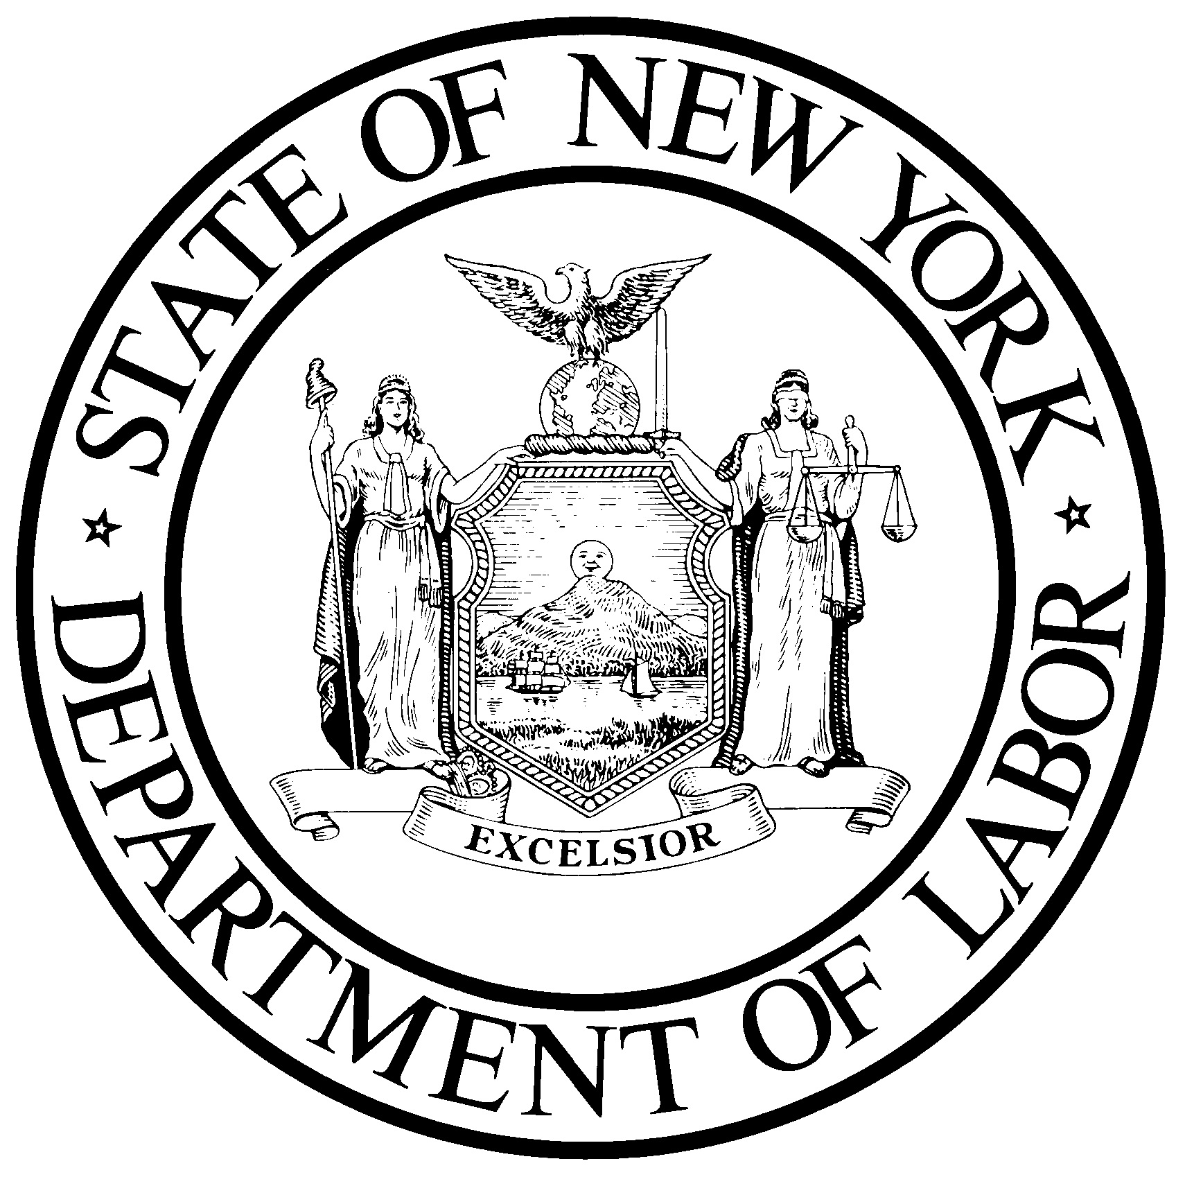
New York State Department of Labor

Job Order Form
New York City Regional Office
9 Bond Street, 4th Floor
Brooklyn, New York 11201

Telephone: (718) 780-9499 Fax: (718) 613-3952 E-mail: nyc.jobbank@labor.ny.gov
www.labor.ny.gov
Business: Please complete one Job Order Form for each job title and email, fax, or mail it back to us. It is only necessary to notify one office of your opening. By using this form to post your openings you will reach all Department of Labor offices. If you prefer to place your job order by telephone, you may use this form as a guide.

Date: Unemployment Insurance Employer Registration No. -
Company
Address City State Zip -
Telephone # ( ) Ext. Fax # ( )
E-Mail Address Type of Business
Contact Person Title
Travel Directions: No. of Employees in Firm

Does your firm have a Federal Contract requiring jobs to be listed with the Department of Labor? FCJL Other
Do you wish to receive information on tax incentives for hiring? Yes No
Title of Job Opening No. of Job Openings: No. to Interview:
Resume by: Mail Fax E-mail Send Direct Call For Appointment List on Internet

Job Description
Please describe your job opening in detail. List special knowledge, skills, aptitudes, abilities required; equipment used or operated; special physical demands or working conditions. Include the worksite location, if different from the company address. Use additional sheets if necessary or attach your job description.
Job descriptions, including tasks:

Job Requirements

Education Required: None HS Diploma/GED AAS BA/BS Masters Ph.D.
Years experience Related experience OK? Yes No If Yes, specify:
Full-Time_______ Part-Time________Regular (Permanent)___________Temporary (From to )
Work Hours: From: To Total hours per week
Overtime: Yes No Circle Work Days: S M T W T F S
Salary Range: From $ To $ Per Salary Negotiable? Yes No

Other Hiring Requirements
Driver License Yes No Class Other Tests Yes No
Own Tools Yes No Must Join Union Yes No
*Physical Exam Yes No Bondable Yes No
*Pre-Screening Drug Test Yes No
Employment/Security Test Yes No Name Other

Benefits
Benefits Yes No (If yes, specify below)
Health Insurance Yes No Dental Insurance Yes No
Paid Vacation Yes No Paid Sick Leave Yes No
Paid Holidays Yes No Retirement Plan Yes No
*Required only after job hire and if relevant to job opening. All Hiring Requirements Must Be Bona fide Occupational Qualifications
ES 515.584 (draft)
New York State Department of Labor
Division of Employment and Workforce Solutions
The information you provide on the other side of this form will help us to understand your hiring need. Please review the information below, and use it as a guide when completing the Job Order form. Then mail, fax, or e-mail the form to the nearest Department of Labor office, or use the form as a guide if you prefer to telephone us with your job order.
Unemployment Insurance Employer Registration Number: Please provide this number when faxing, calling, or e-mailing in a job order. This verifies that you are authorized to operate within New York State. If you are a new employer and have just applied for this number, please advise us; we will use your Federal Tax I.D. number on an interim basis.
Referral Instructions: On job listings made available for job seekers’ review, the Department of Labor will provide the employer’s name, address, and contact information unless you tell us not to. This will allow employers the opportunity to receive direct inquiries from qualified job seekers and will additionally increase the volume of job seeker responses to posted openings
Referral Results: It is critical for us to get feedback concerning the quantity and quality of the referrals that we make to your company. This will help us in our constant goal of improving our service to you and to the business community. For this reason, if we do not hear from you about referral results, Department of Labor staff may contact you for this information.
National Exposure: Your job will be posted on the National Labor Exchange (us.jobs), which serves as a network for other state public job banks. Your job openings will reach a nationwide audience of job seekers.
Veterans Preference: The Department of Labor makes every effort to find the most suitable candidates for your job opening(s). Our job seeker file contains military veterans skilled in many occupations and job duties. Department of Labor policy is to refer qualified veterans to job openings before qualified non-veterans.
Benefits: To attract the best applicants, it is important for you to let potential employees know the benefits that you offer with your job. To some individuals, the benefits you provide may be more important than salary.

Technology
The New York State Department of Labor helps employers fill thousands of job openings with qualified workers each year. Like any other service agency, we are always looking for ways to make our operation more efficient and responsive to the people we serve. As part of this continuing effort, we have introduced some enhancements for matching candidates to job openings, using computer technology:
- Computer Matching – A computerized notification system that alerts potential candidates of your job opening, matching your job requirements with an applicant’s special skills and abilities.
- Internet – Job openings listed with the Department of Labor can be viewed on our Internet Home Page. This web site includes a direct link to our State Job Bank (ny.jobs) as well as a variety of resource information for both employers and job seekers. Visit our web site at www.labor.ny.gov.

Disclaimer
In conducting placement activities, the New York State Department of Labor, acts as a portal for prospective employees and businesses. The department does not represent or guarantee the truthfulness, accuracy, or reliability of information supplied by prospective employees or businesses, nor does it engage in any form of screening or independent investigation of prospective employees and businesses other than matching a prospective employee’s self-stated qualifications to those prescribed by a business. The department is not responsible for any employment decisions made by prospective employees or businesses, for whatever reason made. New York State Law may limit the types of disclosures that the department can make to a business regarding a prospective employee. Businesses should not forgo any form of screening otherwise prudent to ensure a prospective employee’s qualifications and background meets the needs of the workplace.

